 **Heaven’s Light is Our Guide**

**Rajshahi University of Engineering and Technology**

**Department of Computer Science and Engineering**

**Course No:** CSE.2202

**Course Title:** Sessional based on CSE.2201 (Computer Algorithms)

**Lab Report No:** 06

**Lab Report On:** N-Queens Problem using Backtracking.

**Submitted By** **Submitted To**

Md. Ariful Islam Biprodip Pal

Roll No: 1803046 Assistant Professor

Section: A Dept. of CSE,RUET

Department: CSE

**Date: 30-07-2021**

* **Source Code:**

|  |
| --- |
| #include<bits/stdc++.h>  using namespace std;  typedef long long ll;  int arr[53]={0};  vector<int>xy;  // function to check the position  bool is_safe(int x,int y, int &n){  bool rslt=true;  int f=1;  for(int k=x-1;k>0;k--){  if(arr[k]==y){  rslt=false;  break;  }  if((x+y)==(arr[k]+k) && y<n){  rslt=false;  break;  }  if(y>1 && arr[k]==(y-f)){  rslt=false;  break;  }  f+=1;  }  return rslt;  }  // recaursive call for n-queen  void N_Q(int a, int &n){  for(int i=1;i<=n;i++){  if(is_safe(a,i,n)){  arr[a]=i;  if(a==n){  cout<<"\nSolution: ";  for(int j=1;j<=n;j++){  cout<<arr[j]<<" ";  }  cout<<"\n"<<endl;  break;  }  else{  N_Q(a+1,n);  }  }  else{  cout<<"Backtrack From Node: ";  for(int j=1;j<a;j++){  cout<<arr[j]<<" ";  }  cout<<i<<endl;  }  }  }  int main(){  int n;  cout<<"Enter N: ";  cin>>n;  if(n>0){  N_Q(1,n);  }  return 0;  } |

* 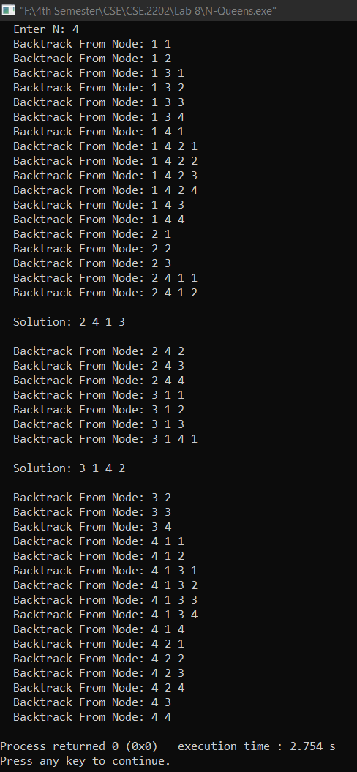**Output:**

**# END #**